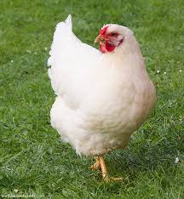
Chicken Mites

These pesky wee critters are a constant source of annoyance and irritation for both chooks and their owners. Whether you’re collecting eggs and find them scuttling around the coop, or you’ve picked up a chook for a look and find yourself with unwanted passengers streaming up your fingers, they are yuck and you’ll want to treat them so here’s what you need to know:
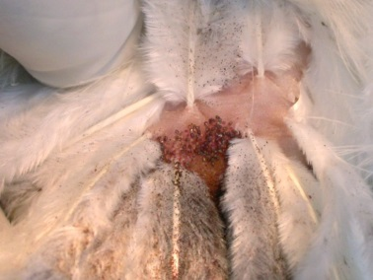
There are 3 kinds of mite that are common in chickens in NZ and they are:
- Northern Fowl Mite- These are little brown mites that spend most of their lives on the host (your chook). They are carried by wild birds and rodents and are often spread by these unwanted visitors coming to eat your chook feed! You won’t find them in the coop so eradication is aimed at treating your chooks and reducing wild bird and rodent access to feed.
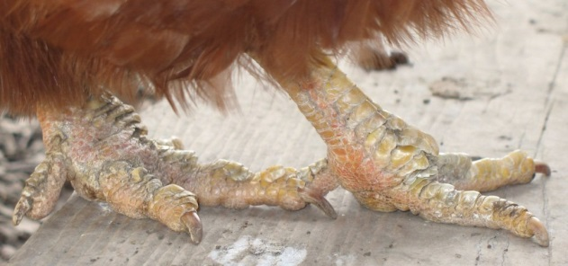
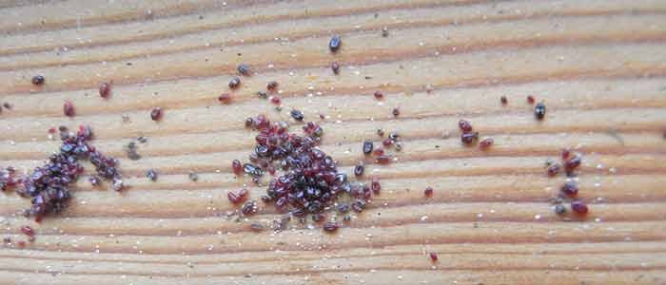
- Red Mite- As the name suggests these are little red mites that primarily live off the chook in the coops. They hide in the nooks and crannies in the wood of the coop during the day, and at night they come out and feed on your chooks. These can be a pain to get rid of, as not only do you have to treat the birds, but also the coop itself, this involves dismantling the coop, and treating with an insecticide.
- Scaley Leg Mite- usually the first sign of a Scaley Leg Mite infection is seeing your chooks have, well, scaley legs. The mites transfer from bird to bird and live under the scales of the legs, living on a diet of your chickens’ skin cells. This can cause significant discomfort to your chooks. Unfortunately they can live off chickens so the coops need to be treated as for red mite.
How do I know which mites are on my chickens?
- Does your chicken have Scaley Legs? If yes then its Scaley leg mite.
- If you go out to the coop at night time and run your finger along under the perches and platforms, and you find little red mites scurrying off your hand, you’ve got red mite.
- If you don’t find any mites in the coop and you pick your chooks up and look around the vent and see little brown mites crawling around, it’s Northern Fowl mite.
- It can be very difficult to tell the difference between Northern Fowl mite and Red mite, unless you have two to compare but Red mite lives primarily in the coop whereas NFM is never in the coop. If in doubt you are best to treat both the birds and the coop.
How do I treat my chickens?
- Your vet can give you medication which will be needed for all 3 types of mite to kill the ones living on the birds.
- It’s safe to assume if one bird has mites, they all do.
- Your coop will need treating if it’s red mite or scaley leg mite.

